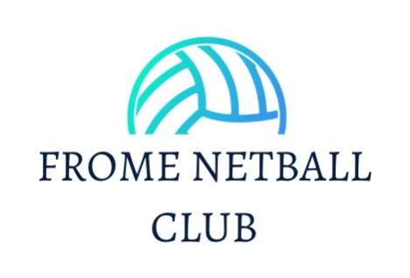

England Netball's pregnancy guidance
Frome Netball Club, in line with England Netball, follow World Netball’s pregnancy guidance, which says – in short – that the decision to play netball during pregnancy is ultimately the participant’s choice and emphasises the importance of seeking medical advice due to the inherent risks.
World Netball’s Pregnancy Guidelines state, “Netball is a physically demanding game which requires a high level of agility. It also involves a degree of contact and carries an inherent risk of accident and injury, both to the participant and the unborn child. Accordingly, participation in netball during pregnancy is at the risk of the participant.” In the same vein, “Maternal and foetal responses to exercise can vary with pre-gestational maternal fitness levels, co-existing medical conditions and/or pregnancy complications. All women are encouraged to seek individual medical advice.”
In accordance with World Netball, England Netball strongly recommends that the pregnant participant:
- consults with their own appropriately qualified medical practitioner to inform them, on a voluntary basis, of their pregnancy and to obtain individual and specific professional medical advice before participating in netball (both during and following pregnancy), in particular regarding the risks of such participation;
- acts in accordance with the medical advice received
- attends regular check-ups with their medical practitioner throughout and following their pregnancy regarding their participation in netball, adjusting participation accordingly.
In accordance to Moonraker League rules:
- Any player who chooses to play whilst pregnant may be allowed to play at central venue as long as they have a letter/ email from their GP to say that they are fit to play netball and this is shown to the umpire prior to the match.
- No player shall play after they are 12 weeks pregnant.
By participating when pregnant, the participant will be deemed to have consented to any risks (including any risk of injury to the participant and/or the unborn child) that may arise from such participation. Aside from liability for death or personal injury resulting from negligence, the participant will also be deemed to have waived any and all claims, causes and rights of action against World Netball, England Netball, event organisers, players and match officials, whether at law or in equity, of whatever nature and in any jurisdiction or forum, that she may have as a result of such participation. Members* should note that England Netball’s centrally arranged programme of insurance excludes any loss or expense due to pregnancy, childbirth, miscarriage, or any consequence thereof.
You can find pregnancy guidance and information on the NETBALLHer website here.
*Personal Members. Excludes Social and Supporting members.

